1. Write a Python program to count the occurrences of each word in a given sentence string = “To change the overall look of your document. To change the look available in the gallery”

**Prog –**

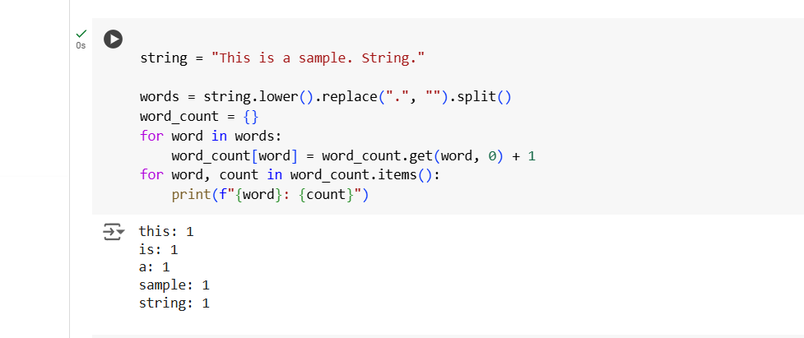

**Output –**



1. Write a Python program to remove a newline in Python String = "\nBest \nDeeptech \nPython \nTraining\n"
2. **Prog –**
3. 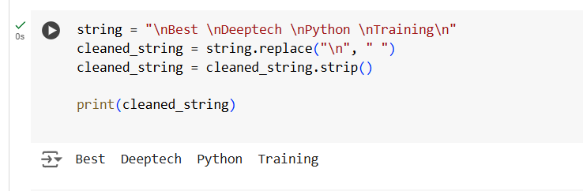
4. **Output –**
5. 

3. Write a Python program to reverse words in a string String = “Deeptech Python Training”

**Prog –**

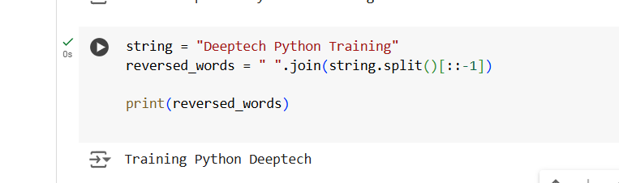

**Output –**



4. Write a Python program to count and display the vowels of a given text String=”Welcome to python Training"

**Prog –**

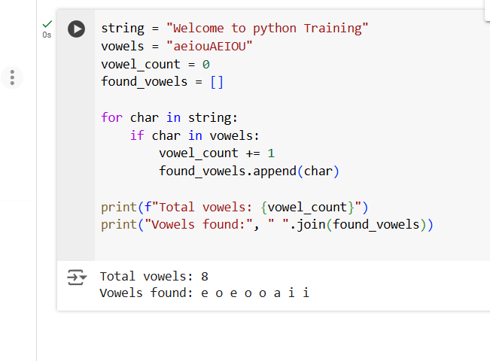

**Output –**

